* 1. Tony Ketteringham

**Overview**

Tony specialises in developing technology architectures and technical solutions for organisations. Tony joins the knowledge gap between the business and technology areas in an organisation.

Tony is an expert in business analysis, technical architecture, project management, management of medium to large teams with a technical focus, management of the complete software development life cycle and IT operations. He has experience in leading and using agile development and project management methodologies and contemporary software development practices.

Tony has worked in a range of roles including IT manager, development team lead, business analyst, product manager, systems administrator and managing and delivering product support. He has worked in small and large public and private organisations up to the executive level of management, and has experience working directly with large internal and external customers.

**Key Competencies/Skills**

* Project management
* Management of software development life cycle
* Software architecture design and implementation
* Hardware architecture design and implementation
* Software analysis and development
* Team management
* 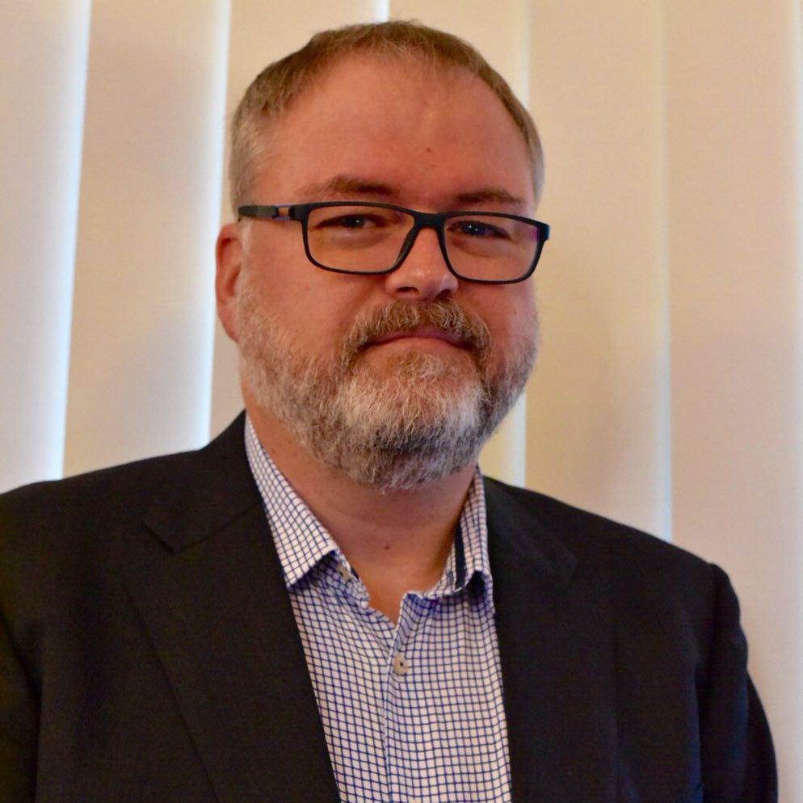Managing and providing product support
* Systems administration

**Example Roles / Assignments**

* Senior Consultant, Integral Technology Solutions, 2013 to 2015
* Consultant, Business Aspect, 2010 to 2013
* Solution Architect, Flight Centre, 2013
* Enterprise Architect, Clean Energy Regulator, 2012 to 2013
* Solutions Architect, Department of Education & Training (QLD), 2010 to 2011
* Project Manager, Jeppesen, 2008 to 2010
* Enterprise Architect, Minol Australia, 2006 to 2008
* Director, Depth of Field, 2003 to 2006
* Chief Technology Officer, ReTech Global, 2002 to 2003

**Education, Qualifications and Memberships**

* Bachelor of Science, Computer Science (Honours), University of Queensland
* PRINCE2 Project Management Practitioner Course
* PRINCE2 Project Management Foundation Course
* ISACA Member